*We offer a unique facility for cancer patients and those patients with life threatening illnesses*
Do you need a holiday or fancy a break?

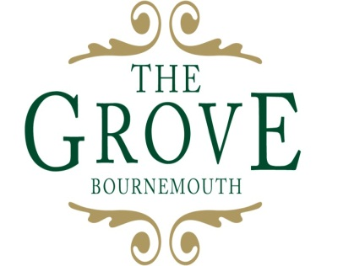
*We offer a unique facility for cancer patients and those patients with life threatening illnesses*

2 Grove Road, East Cliff, Bournemouth, BH1 3AU
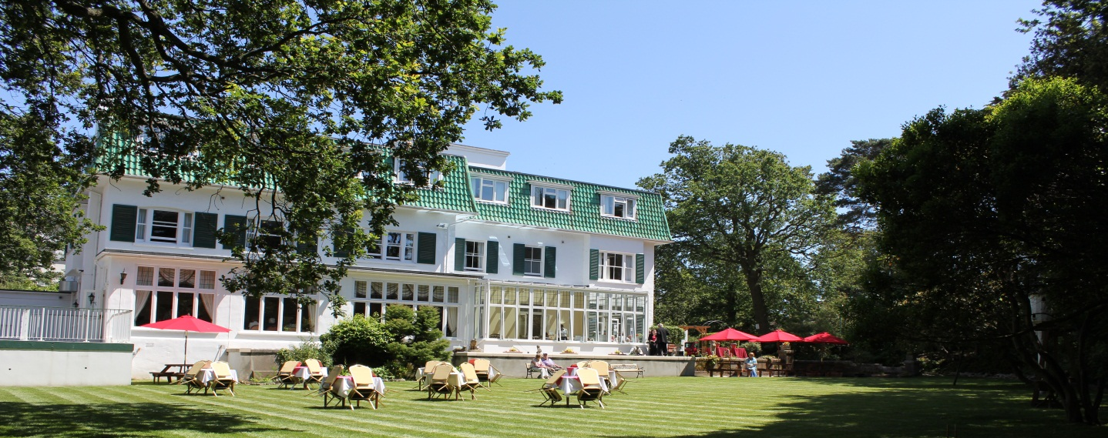
Do you have or have you had a cancer diagnosis? Do you have a life limiting/threatening illness? If you need a holiday or just a break why not join us at The Grove Bournemouth. You can come on your own or spend time with your family, friends, and carer, everyone is welcome.
We are a unique hotel that provides that special holiday just when you need it the most. We are owned by a small registered charity Macmillan Caring Locally. Our tariff is very reasonable as we are non-profit making hotel, where you can book for a short or long break, whatever you choose you will always be very welcome. You can eat delicious food in our beautiful garden restaurant prepared by our chefs to meet your dietary requirements. It’s a place where you can have fun and make new friends, spend time on the beach relaxing in our beach hut, play croquet on the lawn, or visit local areas and beauty spots on our free coach trips. All of this secure in the knowledge that there is a nurse on duty 24/7 for advice and support, someone who understands the difficulties you may be experiencing. Our friendly staff work extremely hard to ensure that you have a holiday to remember with lots of lovely memories to treasure.
We have 30 bedrooms, all en-suite with three of them fantastically equipped for our less able guests with en-suite wet rooms and riser recliner chairs. We are situated in the heart of Bournemouth close to glorious beaches and golden sand, and near to theatres, cinemas and shops. Or if you just want to take it easy, The Grove is the place to relax, unwind and recharge.
If you would like to find out more about The Grove and are interested in joining our Just Grove Friends network, please telephone 01202 552233 or visit our website www.thegrovebournemouth.co.uk or follow us on Facebook or twitter.

The Grove
The Grove is a very special place, it is an hotel that provides holidays for people with cancer or life threatening/limiting illnesses nationwide. Guestscan come with their families, friends, carers or alone if they wish. Everyone is welcome at The Grove, it has a family atmosphere and guests often become friends of the hotel.
“We are so grateful for being able to stay in such a wonderful hotel with such amazing staff, we couldn’t wish for more.”
“All of the staff I have met are wonderful, so helpful –caring and kind –they are all stars –I would recommend The Grove thanks a million.”
“We had one of the best holidays ever from the moment we arrived.
“This has been our first chance of a holiday in 3 years. Thank-you for making it so amazing.”
“It shows how much thought and determination has gone in to making it a brilliant place to stay.”

