Template and suggestion letter for the Waitrose Community Matters scheme
My name:
My address:
Telephone:
Email:
Date ..…….………………
Attn of the Manager: …………………..……
Name of Waitrose Branch:………………………..
Re: Community Matters Scheme

Dear ………………….……,
I am writing to see whether your …………………………………….branch of Waitrose would include the charity “MDS UK Patient Support Group” as one of your nominated charities for the monthly ‘Community Matters’ collections. I have also included a brief description about Myelodysplastic Syndromes and the work of this charity.
Why I would like this branch of Waitrose to include MDS UK in the Community Matters Scheme:
How MDS UK has helped me and my family/friends:
Information about myself and how I am connected to MDS:
Reason why I am connected to this particular Waitrose branch:
MDS stands for ‘ myelodysplastic syndrome’ - the medical name for this type of blood cancer and bone marrow failure. The charity, based at King’s College Hospital in London provides:
- A networking service through which those who are newly diagnosed with MDS can share their experiences with others suffering the same illness,
- A help and contact line 5 days a week - we found this invaluable when we needed simple advice to interpret difficult medical terminology and the prognosis,
- National patient and family information meetings on a regional basis,
- Help to create smaller local support groups for patients and their families,
- Access to a list of UK consultants who specialise in this illness.
There is no simple cure for MDS, sufferers need to have regular blood transfusions to top up their white and red blood cells. I’ve attached the nomination form.
Please contact me if you need any further details, I would be happy to help.
Thank you for taking time to read this letter and for providing a great service in your store,
Kindest regards,

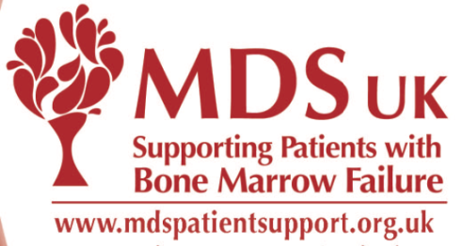
MDS UK Patient Support Group

Every year around 2,500 patients are diagnosed with Myelodysplastic Syndrome (MDS), a rare cancer which causes bone marrow failure. It mainly affects people over 60. It causes overwhelming fatigue, infections and bleeding. MDS significantly reduces lifespan and may progress to acute leukaemia. There is no cure, apart from a Bone Marrow Transplant, which is only suitable for very few people. Many patients have palliative chemotherapy or undergo regular blood transfusions. Most people have not heard of MDS nor have their GPs so informed support is vital.
We provide:
- information about the disease and current treatments
- a helpline
- the opportunity for patients and carers to meet locally for emotional support.
- Lobbying for new drugs and treatments
- A website covering all aspects of MDS
- An online message forum for patients and carers to talk to each other

Charity No. 1145214 Website: www.mdspatientsupport.org.uk
Tel: 0207 733 7558 Email: mds-uk@mds-foundation.org

